LAB 3 – Giurgiu Ravzan 30422

In this lab we implemented 3 rectifiers :

1. Filter rectifier using only a capacitor

* The capacitor stores energy during the time intervals in which the voltage supplied is grater than the capacity of the condensator.
* It is more expensive to implement in large scale aplication

Code:

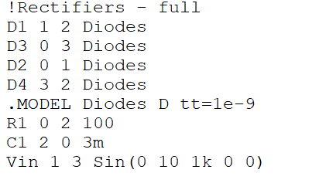

Plot :

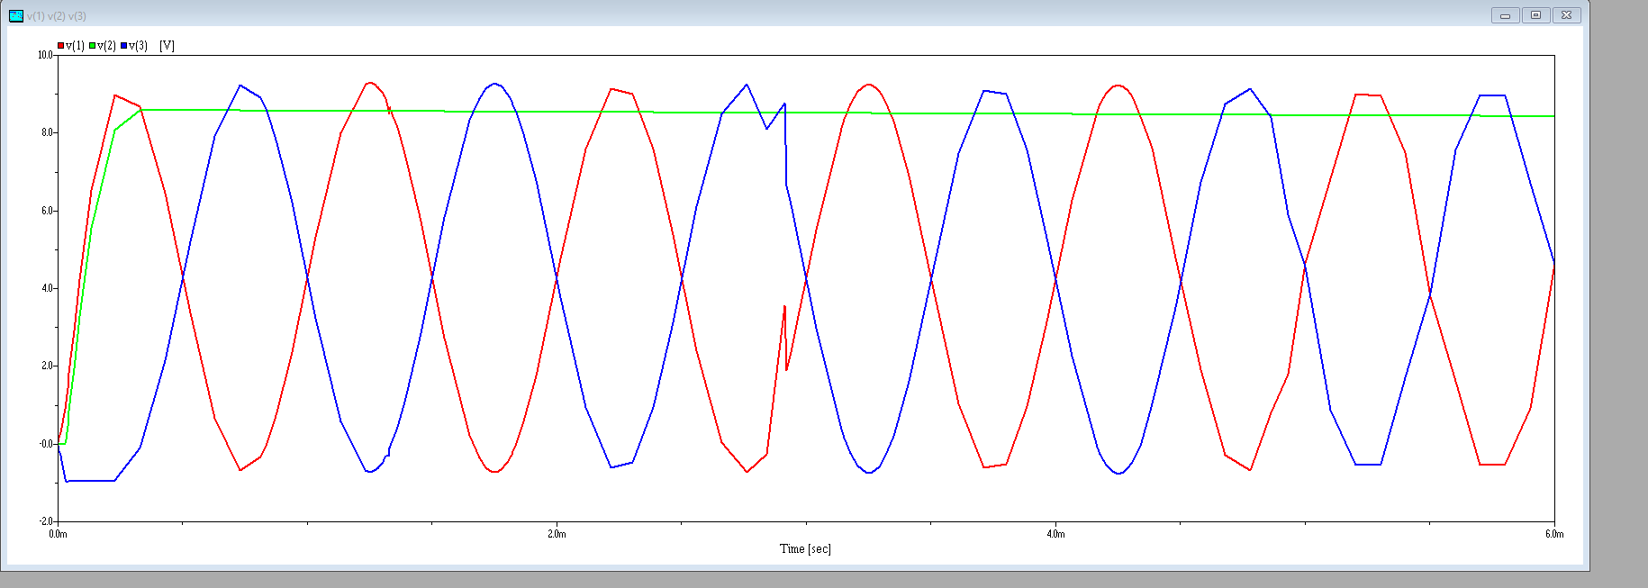

1. Parametric regulator with Zener Diode

* Based on the zener diode curent , current can flow in one way with maximum voltage of the diode in when it is revers bias-ed.
* We are still using an capacitor but the voltage is less stable

Code:

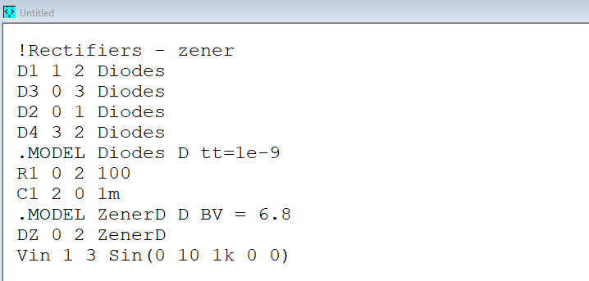

Plot :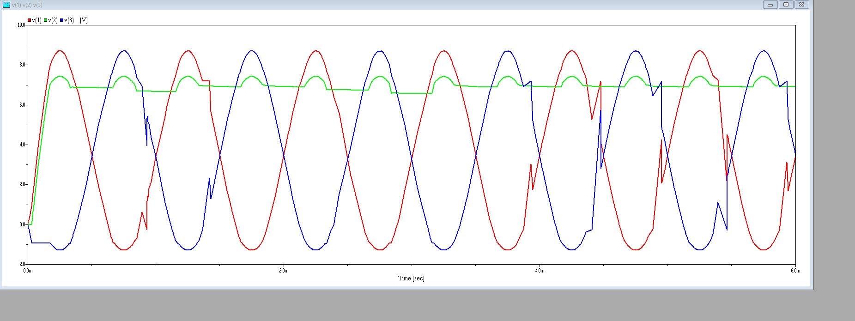

1. Reaction regulator with no error amplifier

* Increasing Vout determine the decrease of VBE, that in turn will increase the VCE and VOUT will decrease
* Similarly when VOUT Decreases
* The system it’s self-regulating itself converting AC to stable DC

Code :

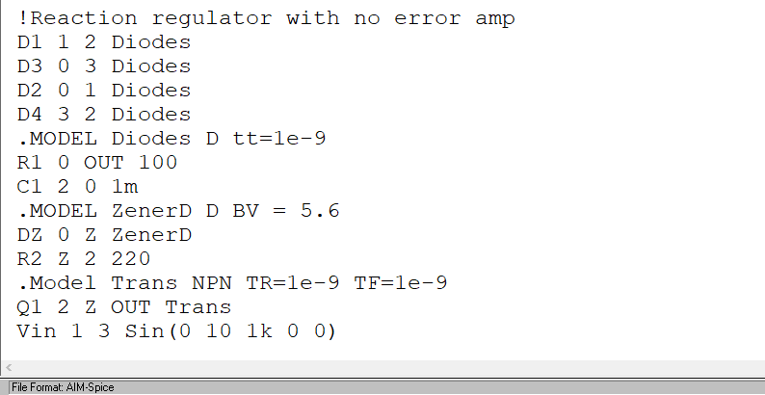

Plots:

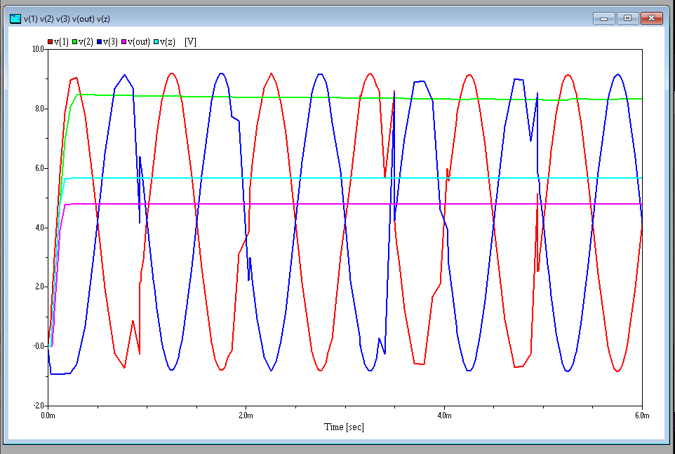

Differnce between V3 and V1:

